Hypothesis:

I believe introducing native bugs to protect your gardens is just as effective as using pesticides to protect your garden.

Materials:

1. 50 Aphids( berkshirebiological.com )
2. 9 pea plants
3. 9 Mason jars
4. Water
5. Gardentech Sevin pesticide
6. Garden soil ( Miracle grow )
7. Round up

IV: amount of pesticides

DV: how the pesticides affect the environment

Control Variables:

1. Amount of aphids
2. Type of plant
3. Type of soil
4. Space
5. Temperature
6. Light exposure
7. Type of pesticide

Procedure:

1. Collect materials
2. Setup 9 mason jars with pea plants and soil.
3. In three jars place only 5 aphids and label
4. In three other jars place 5 aphids and sevin pesticide. Label only 3 ml of pesticide
5. In the last three jars place 5 aphids and round up. Label only 3 ml of pesticide
6. After filling each jar add 20 ml of water and cover with thin paper towel
7. Place all jars in a sunny room without direct sunlight
8. Record results for three days. On second day add 20 ml of water

Table:

|  |  |  |  |
| --- | --- | --- | --- |
|  | Day 1 | Day 2 | Day 3 |
| Jar 1 aphid | 5 | 5 | 5 |
| Jar 2 aphid | 5 | 4 | 4 |
| Jar 3 aphid | 5 | 5 | 5 |
| Jar 4 round up | 5 | 4 | 4 |
| Jar 5 round up | 5 | 5 | 4 |
| Jar 6 round up | 5 | 5 | 5 |
| Jar 7 sevin | 5 | 4 | 3 |
| Jar 8 sevin | 4 | 3 | 3 |
| Jar 9 sevin | 5 | 4 | 2 |

After experimentation for the first day all plants survived with little to no effect of the aphids. Almost all aphids survived the first night except for one aphid in jar 8.

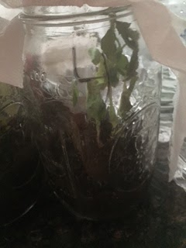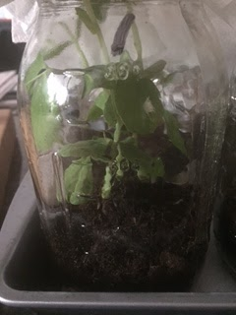

After day 2 of experimentation every jar with Sevin pesticide lost 1 aphid. All plants look healthy with little to no damage. One aphid lost in jar 2 and 4.

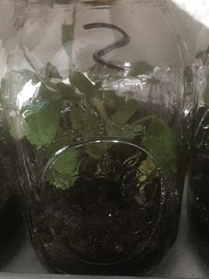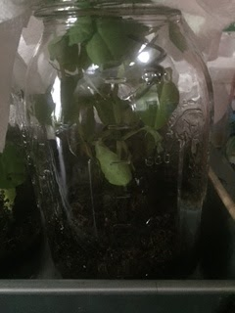

Day 3 of experimentation all plants look healthy in jars 8 and 9. In the remainder of jars some of the plants have started to tilt and collapse on one side of the jar. Brown leaves in certain areas. Only jars one three and six have all 5 bugs alive. In jar 9 two bugs died overnight.

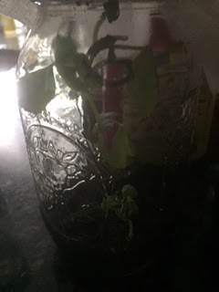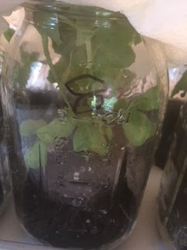

After three days of experimentation judging from my results I can conclude that every jar with sevin pesticide inside, the plant was in the healthiest state besides jar 7 which had two brown leaves. Every plant was damaged in some way but the healthiest plants were in the jars 8 and 9. Jars 8 and 9 also had the least amount of aphids alive by the end of the three day experiment. My results are valid because every plant had the same treatment. The temperature during the experiment was 73 degrees fahrenheit. All plants were kept in a sunny room without direct sunlight. Every jar was covered with a thin paper towel. Each jar had the same plant and soil. Every jar was given the same amount of water at the same time. All jars had 5 aphids and for each jar with pesticide we used 3 ml. The experiment was controlled and all the results are valid.

For my experiment I tested the effect of non natural pesticides on aphids in gardens. Every jar with non natural pesticide the plant survived with little to no damage from the aphids. The pesticide proved to be a good way to combat the pests that want to harm your plants. Every jar without pesticide was effected by the aphids.